.r

COMMITMENT/AGREEMENT FORM
PARTICIPANTS

I ________________________an undergraduate student in _______________, of legal age, citizen of the United Stated and resident of ____________________ have been accepted to be part of the PR-LSAMP/ROUSS program under the direction of Dr. Juan S. Ramírez Lugo.

As a participant of the PR-LSAMP/ROUSS I will commit to:

- To belong to only one federal program during the period I participate in PR-LSAMP. If accepted into another federal program, I will notify immediately. I am aware that federal research agencies prohibit participation in two programs simultaneously.

- Comply with the requirements established by research mentor regarding the hours to be dedicated to the research work in the laboratory.

- Actively participate of seminars and workshops organized by PR-LSAMP program and home institution.

- Maintain a GPA of 3.10 or more.

- At the end of each semester, the student must download the form Student Progress Report from the website, fill the information and submit it through the PR-LSAMP profile for the research mentor approval.

- Participants must present their research work at the annual Puerto Rico Interdisciplinary Scientific Meeting / Junior Technical Meeting (PRISM/JTM).

- Complete the surveys and provide feedback to the program.

- Participate in TANIA project.

- Regularly update their profile in the program website to include any publications, presentations, awards, or any change on their personal information.

I understand that:
- The Director of PR-LSAMP can cancel the request for any stipend and my participation in this program if I do not comply with any of the commitments detailed in this agreement form or violate any of the University of Puerto Rico regulations.
- I can cancel my participation in this program if fully justified reasons are provided and discussed and approved by my mentor.
- My mentor must approve the final semester report to receive the stipend.

This commitment/agreement will be effective UNTIL MAY 31st , 2024

_________________________ __________
PR-LSAMP/ROUSS Date
Participant Signature

_______________________
Name Student’s Mentor

_______________________ __________
Signature Student’s Mentor Date

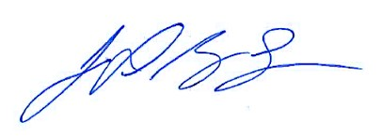

Juan S. Ramírez Lugo
Director PR-LSAMP

